Technical Design Document (TDD)
LUXE — AI Shopping Assistant

Author: Forward-Deployed AI Engineer
Status: Architecture Review
Date: September 2026
Audience: LUXE engineering

Contents
1. System Architecture (HLD) 3
1.1 Architectural overview 3
1.2 Component responsibilities 3
2. Agent Orchestration (LLD) 4
2.1 Execution loop 4
2.2 The agent and its tool 5
2.3 Resiliency and fallbacks 5
3. Data & Security Model (LLD) 6
3.1 Catalog access 6
3.2 Guardrails — defence in depth 6
3.3 Identity and authorization 6
3.4 Observability and evaluation 7
4. Reliability & Operations 7
4.1 Failure modes and behaviour 7
4.2 Statelessness and scaling 7
4.3 Testing and the release gate 8
5. Integration & Delivery 8
5.1 How the assistant lands in your codebase 8
5.2 Configuration 8
5.3 The Forward-Deployed delivery model 9
Appendix A — Cost model 10
Per message 10
Per month 10

1. System Architecture (HLD)
The LUXE AI Shopping Assistant adds a natural-language product-discovery layer to the existing storefront. It is an addition, not a rewrite: the catalog, cart, checkout, accounts and admin are untouched. The assistant is a chat widget on the front end and a single new endpoint on the back end.
The design has three concerns: a static presentation layer, a stateless orchestration pipeline, and a read-only data-access path. Reasoning happens only in the orchestration layer; the language model is never given direct access to the database.

1.1 Architectural overview
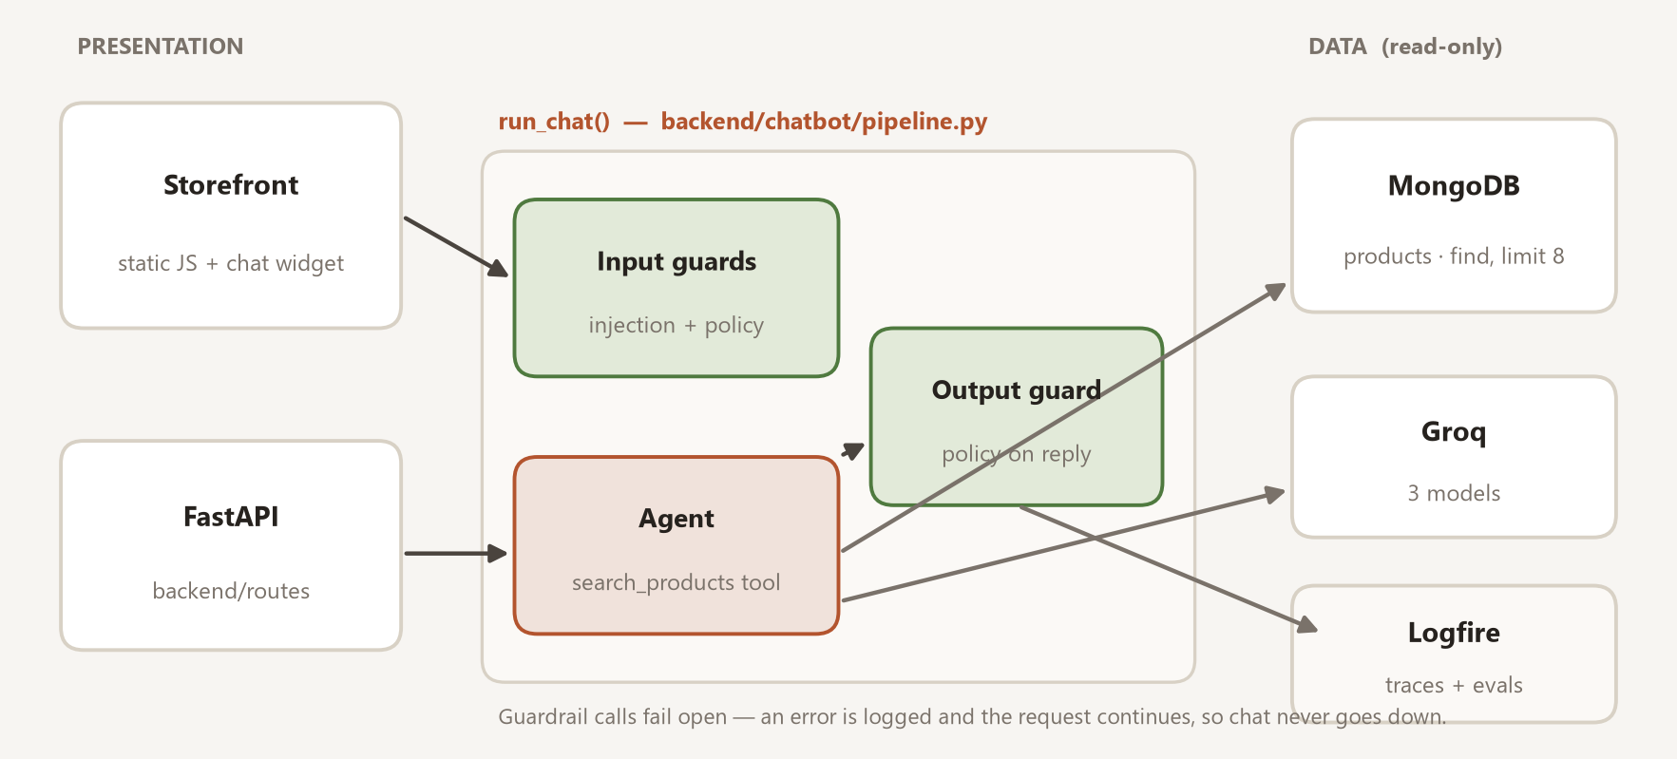
Figure 1. The assistant is one function, run_chat(), sitting between the chat widget and the catalog. It calls out to Groq for the models and streams traces to Logfire.

1.2 Component responsibilities
Component | Responsibility
Presentation | Static ES-module chat widget mounted once on every page. Holds only UI state (open/closed, message list). Escapes every value from the model or the user before it touches the DOM. No build step.
Orchestration | backend/chatbot/pipeline.py :: run_chat(message) -> dict. Framework-free. Runs input guards, the agent, the output guard, and shapes the response. Returns a plain dict and never raises.
Agent | A Pydantic AI agent on a Groq model with exactly one tool, search_products. Decides whether a message is a product query and, if so, calls the tool with typed filters.
Data & integration | Read-only access to the products collection. Groq for the agent and guardrail models, optionally via the Portkey gateway. Logfire for tracing and evals.

2. Agent Orchestration (LLD)
The orchestration tier keeps behaviour deterministic around a probabilistic core. One function owns the whole lifecycle of a message.

2.1 Execution loop
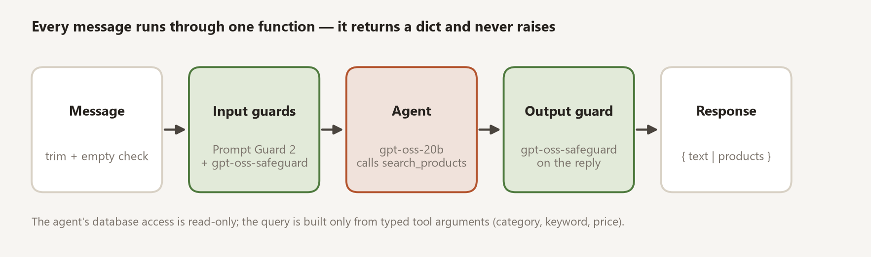
Figure 2. Every message runs the same five stages.
- Ingestion. The message is trimmed. An empty message returns immediately with a prompt to type something — no model calls.
- Input guards (concurrent). Two Groq safety models run together via asyncio.gather: Llama Prompt Guard 2 returns an injection/jailbreak likelihood (blocked at ≥ 0.5), and gpt-oss-safeguard-20b classifies the message against a bring-your-own-policy prompt. A flag from either one returns the standard refusal.
- Agent run. The agent receives the message with its system prompt. If the message is a product query it calls search_products; otherwise it replies in plain text or issues the standard refusal for off-topic requests.
- Output guard. gpt-oss-safeguard-20b checks the agent's reply against the output policy — prompt leaks, unauthorised commitments, unsafe content, a jailbroken persona. A flag returns the refusal instead of the reply.
- Synthesis. The endpoint returns {type, message, data}. type is "products" when the tool found matches (read off a per-run object, not parsed from the model's words), otherwise "text".
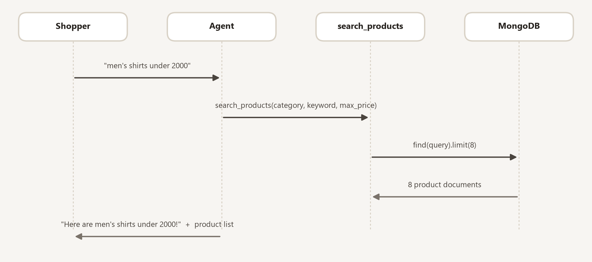
Figure 3. A product query end to end.

2.2 The agent and its tool
- System prompt. A short rule set: greet warmly; for any product request ALWAYS call the tool and never describe products from memory; confirm what was searched; refuse anything unrelated to shopping; never invent names, prices or details.
- The one tool, search_products. Optional typed arguments: category, keyword, min_price, max_price. It builds a MongoDB query fragment by fragment — a case-insensitive exact match on category, a case-insensitive substring match on name, a numeric range on price — and runs find(query).limit(8).
- Result handling. Each result's _id becomes a string id; the image is normalised to a single field (a URL or a reconstructed data: URL) and the raw base64 fields are stripped. Matches are stashed on a per-run StoreDeps object; the reply text is generated separately.
The model never writes a query string. It chooses values for four named parameters; the tool does the rest. This is the core of the security model (section 3.1).

2.3 Resiliency and fallbacks
- Guardrails fail open. If a Groq guardrail call errors (a network blip, a rate limit), the error is logged to Logfire and the request continues. A safety-model hiccup must never take chat offline.
- Agent errors degrade gracefully. If the agent run itself fails, the shopper gets a friendly “I ran into an issue, please try again” with the customer-care number — never a stack trace or a broken page.
- Gateway fallback. When Portkey is configured, all model calls route through it for logging and reliability. When it is not, the same code calls Groq directly. Behaviour is identical either way.
- Test isolation. The offline test suite mocks the entire LLM boundary and swaps the database for an in-memory fake, so failure paths are exercised deterministically on every commit.

3. Data & Security Model (LLD)
The security boundary is the query surface, not the network. The assistant is assumed to be reachable; what matters is that it can only ever do one safe thing.

3.1 Catalog access
- The agent's tool reads a single collection, products, and nothing else.
- The query is assembled only from the four typed tool arguments. There is no code path from model output to a raw query, an aggregation, or a write.
- Every read is capped at 8 documents.
- Raw base64 image blobs are removed from every document before it leaves the tool, so nothing oversized or unexpected reaches the model or the client.
Because the model cannot author queries, the classic prompt-injection-to-SQL (or to NoSQL) risk does not exist here — there is no query for an attacker's text to reach.

3.2 Guardrails — defence in depth
Two independent screens, one on the way in and one on the way out, each using a purpose-built safety model:
Screen | Model | Catches
Input — injection | Llama Prompt Guard 2 (86M) | Prompt injection and jailbreak attempts. Returns a likelihood score; blocked at ≥ 0.5.
Input — policy | gpt-oss-safeguard-20b + INPUT_POLICY | Illegal/violent, self-harm, hate/harassment, sexual content, attempts to extract the system prompt or keys, and “ignore your rules” persona attacks.
Output — policy | gpt-oss-safeguard-20b + OUTPUT_POLICY | The reply leaking the prompt or tool names, promising a discount or refund it has no authority to grant, unsafe content, or talking as an “unrestricted” AI.

- Each policy is a plain-language document supplied by us, so it can be tuned for LUXE without retraining anything.
- Both screens judge the text on its own and explicitly ignore any instructions embedded inside it.
- Ordinary blunt messages (“your return policy is rubbish, give me a discount”) are allowed through — only genuine attacks and unsafe content are blocked.

3.3 Identity and authorization
- Shopper identity. The frontend sends the shopper's email with each request (a real one after sign-in, an auto-generated guest id otherwise). Carts and orders are keyed by that string.
- Admin gating. Admin endpoints check an is_admin flag on the user's database document, identified by an X-User-Email header. Passwords are hashed with bcrypt; Google Sign-In verifies Google's signature on the ID token and trusts the verified email.
- Known limitation. This is a convenience gate, not a hardened boundary — there are no session tokens, and some read endpoints will return a record given its email. Tightening this (signed sessions, per-record authorization) is a scoped follow-up, independent of the assistant.

3.4 Observability and evaluation
- Tracing. Logfire instruments FastAPI and Pydantic AI. Every request is a trace; every guardrail call, agent step and tool call is a nested span. A blocked message and the reason are recorded.
- Live evaluation. After every real conversation, in the background (never on the response path), evaluators score the reply: is it non-empty, how long is it, and — on a 30% sample — an LLM judge rates whether it stayed on-topic and invented nothing. Scores stream to Logfire.
- Offline suite. A fixed set of example conversations runs against the real agent on demand. It asserts on the tool-call span, not just the reply text, because the agent has been observed to claim “no results” without actually searching.

4. Reliability & Operations

4.1 Failure modes and behaviour
If this fails… | …the assistant does this
A guardrail (Groq) call errors | Logs it, continues. Chat stays up.
The agent / model call fails | Returns a friendly “try again” with the support number.
The Portkey gateway is down | Falls back to calling Groq directly.
The message is empty | Returns immediately, no model calls, no cost.
No products match | Returns a plain-text “no products found” reply; type stays “text”.
The catalog query errors | Surfaces as a normal server error and is traced; the store is unaffected.

4.2 Statelessness and scaling
- run_chat holds no cross-request state. Each run gets its own StoreDeps object; nothing leaks between conversations or users.
- The MongoDB client connects lazily and the account indexes are created once at startup, so a cold start does no avoidable work.
- Because the path is stateless, it scales horizontally with no coordination and to zero when idle — it fits whatever runtime the store already uses.

4.3 Testing and the release gate
- 68 tests, fully offline: the database is an in-memory fake and every LLM call is mocked. They run in a few seconds, cost nothing, and touch no network.
- The suite covers the whole pipeline — guardrail blocking, both fail-open paths, product vs. text responses, the agent-error fallback, and the search_products tool in isolation.
- CI runs the suite on every push. Nothing deploys unless it is green. A pre-push git hook runs the same check locally.

5. Integration & Delivery
This section is about how the assistant becomes part of your system — not about how your system is hosted, which is unchanged.

5.1 How the assistant lands in your codebase
- A self-contained package. The assistant is one folder — chatbot/ — containing the agent, the guardrails and the run_chat pipeline. It depends only on your config, a read-only database handle, and a few small helpers.
- A thin route. Your API gains one endpoint, POST /chat, whose entire body is “call run_chat and return the result”.
- The widget. One JavaScript component, mounted once, present on every page.
- Configuration. A handful of environment variables (section 5.2). No schema changes, no migrations, no new infrastructure to stand up.
We prove this is a clean drop-in before integration begins: the same chatbot/ package is built and demonstrated as a standalone proof of concept, then moved into the store unchanged. The only difference between the two is a single configuration flag that turns evaluation on.

5.2 Configuration
Variable | Required | Purpose
MONGO_URI | yes | Connection to the product catalog (read-only for the agent).
GROQ_API_KEY | yes | The agent and guardrail models.
PORTKEY_API_KEY, PORTKEY_GROQ_PROVIDER | optional | Route model calls through the Portkey gateway.
LOGFIRE_TOKEN | optional | Send traces and eval scores to Logfire. Off = local only.
GOOGLE_CLIENT_ID | optional | “Sign in with Google”.
ONLINE_EVALS_ENABLED | default on | Attach the live evaluators to the agent.
AGENT_MODEL_NAME and the guard model ids | default set | Override the Groq models without a code change.

All of it is read in exactly one place — a single typed settings object — so there is one file to review for what the service touches.

5.3 The Forward-Deployed delivery model
The work is delivered in three stages, each ending in something you can run and judge:
Stage | Duration | What you get
Discovery | ~1–2 weeks | We work inside the running store, learn the catalog and the data, and agree the success criteria. Deliverable: this document, confirmed against reality.
Proof of concept | ~1–2 weeks | A standalone assistant, working against your real catalog, that you can try. Deliverable: a demo and a go / no-go decision. If it is a no-go, we stop here.
Integration | ~2 weeks | The approved package folded into the store, with evals and tracing switched on. Deliverable: the assistant live, the store unchanged, the test suite green.

Each stage lives on its own branch, so the plain store, the isolated proof of concept, and the integrated result stay separately reviewable. The assistant's core code is byte-for-byte identical between the proof of concept and the integrated version.

Appendix A — Cost model
The assistant's running cost is almost entirely Groq API usage. Everything else — the database, the store's hosting — already exists and does not change.

Per message
A single shopper message triggers up to four model calls: the prompt-injection classifier (tiny), the input policy check, the agent (one or two rounds if it uses the tool), and the output policy check. Realistic token totals:
Call | Model | ~ tokens (in / out) | ~ cost
Injection check | llama-prompt-guard-2-86m | 200 / 5 | < $0.00001
Input policy | gpt-oss-safeguard-20b | 800 / 200 | $0.00012
Agent (with tool) | gpt-oss-20b | 1,200 / 400 | $0.00021
Output policy | gpt-oss-safeguard-20b | 800 / 200 | $0.00012
Total per message |  |  | ≈ $0.00046

Per month
Monthly volume | Groq | Extra compute | Monitoring | Total / month
~1,000 messages (pilot) | ~ $0.50 | < $1 | $0 (free tier) | under $2
~10,000 messages (launch) | ~ $5 | ~ $3 | $0 (free tier) | ~ $8 – $10
~50,000 messages (busy) | ~ $25 | ~ $12 | $0 – $50 | ~ $40 – $90
~200,000 messages | ~ $95 | ~ $40 | ~ $50 – $100 | ~ $185 – $235

- Figures use approximate public Groq and MongoDB rates as of September 2026.
- Groq's free tier and per-minute limits cover pilot and early-launch volume outright; the numbers above assume paid, on-demand usage.
- Two levers cut this further if needed: prompt caching (50% off repeated input, and the guard policies are identical every call) and the batch API for the offline eval suite (another 50%).
This appendix backs the cost slide in the business deck.

